Unit 2: Network Models and Protocols
Mini-Project Report
Name – Nandini Samir Nikumbh
PRN – 2125UCSF1081
Subject – NPC
To capture and analyze network packets using Wireshark, identify the TCP three-way handshake (SYN, SYN-ACK, and ACK), locate an HTTP GET request, and identify the source and destination IP addresses and Transport Layer ports.

2. Introduction
Wireshark is a network protocol analyzer used to capture and inspect network traffic. It displays packets exchanged between devices and allows protocols such as TCP and HTTP to be examined. In this practical, HTTP traffic generated by visiting a non-HTTPS website was captured and analyzed.

3. Tools / Requirements
- Windows computer with an active Internet connection
- Wireshark Network Analyzer
- Npcap packet-capture driver
- Google Chrome browser
- HTTP test website: http://neverssl.com

4. Procedure
1. Installed Wireshark.
2. Opened Wireshark and selected the active Wi-Fi network interface.
3. Started packet capture.
4. Opened http://neverssl.com in Google Chrome to generate HTTP traffic.
5. Stopped the capture after the website loaded.
6. Applied the display filter tcp.port == 80 to isolate TCP traffic associated with HTTP port 80.
7. Located the TCP three-way handshake: SYN, SYN-ACK, and ACK.
8. Selected the HTTP GET packet and inspected its source/destination IP addresses and TCP ports.

5. TCP Three-Way Handshake Analysis
TCP uses a three-way handshake to establish a reliable connection. The client first sends a SYN packet, the server responds with SYN-ACK, and the client responds with ACK. The captured traffic clearly shows this sequence.
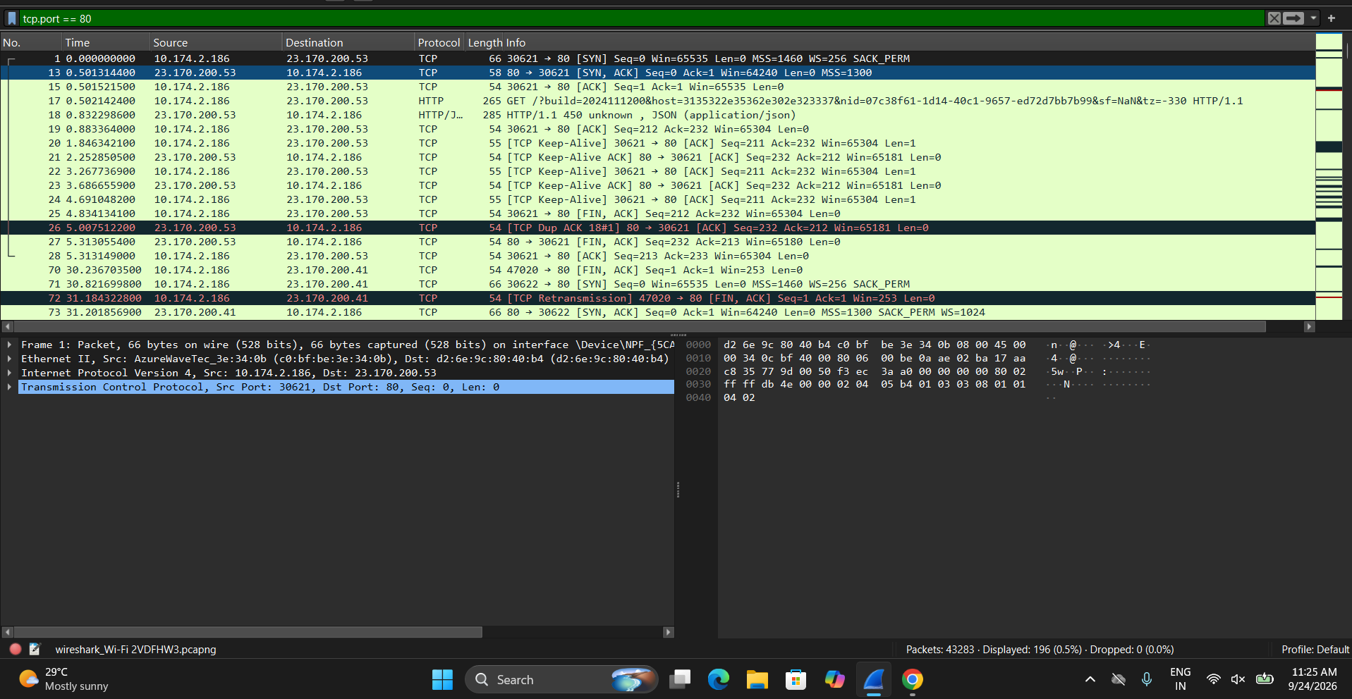
Figure 1: Captured TCP three-way handshake and HTTP traffic
In Figure 1, the client 10.174.2.186 sends a SYN from source port 30621 to server 23.170.200.53 on destination port 80. The server responds with SYN-ACK, and the client completes the handshake with ACK.

6. HTTP GET Request Analysis
After the TCP connection was established, the client sent an HTTP GET request to request a web resource. The packet details show the HTTP layer and the underlying TCP source and destination ports.
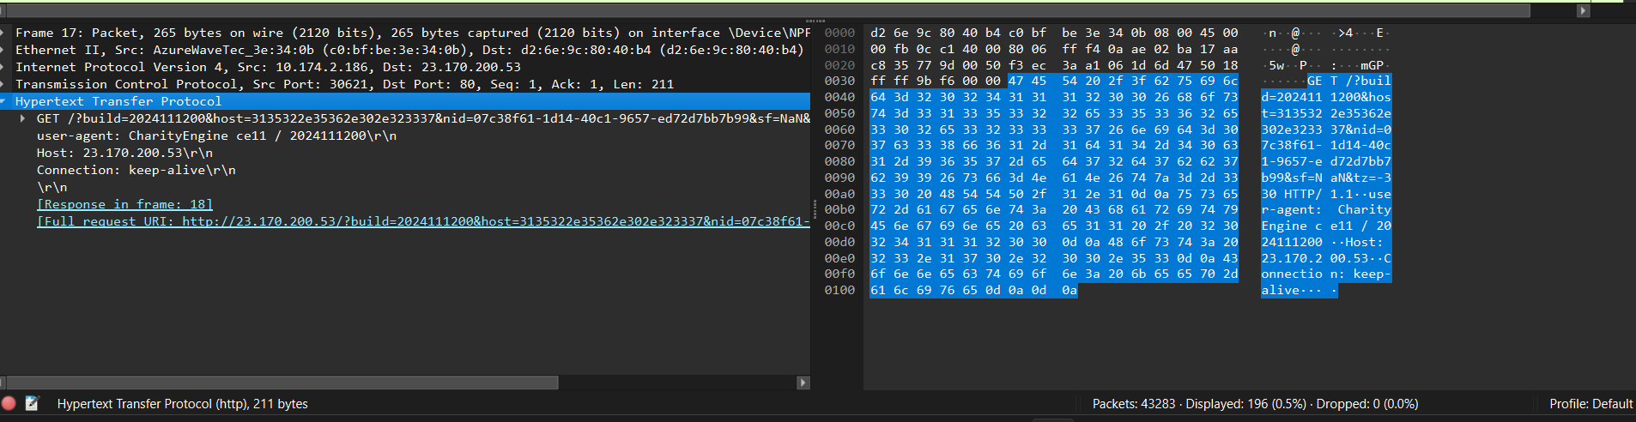
Figure 2: HTTP GET request with source/destination IP and TCP port information

7. Packet Observation
Parameter | Observed Value
Source IP Address | 10.174.2.186
Destination IP Address | 23.170.200.53
Transport Protocol | TCP
Source Port | 30621
Destination Port | 80
Application Protocol | HTTP
HTTP Method | GET

8. Explanation of Important Concepts
TCP: Transmission Control Protocol. It provides reliable, connection-oriented communication.
SYN: A TCP flag used to initiate a connection.
SYN-ACK: The server's response acknowledging the SYN and indicating that it can establish the connection.
ACK: Acknowledgment confirming receipt and completing the TCP handshake.
HTTP: Hypertext Transfer Protocol used for web communication.
GET: An HTTP request method used by a client to request a resource from a server.
Port 80: The standard TCP port associated with HTTP.

9. Brief Summary
Wireshark was used to capture and analyze HTTP traffic. The TCP connection was established using the three-way handshake: SYN, SYN-ACK, and ACK. After the connection was established, the client sent an HTTP GET request. In the analyzed packet, the source IP address was 10.174.2.186 and the destination IP address was 23.170.200.53. The client used source port 30621, while the server used destination port 80.

10. Exported Capture
The packet capture was exported from Wireshark in .pcapng format. The exported capture can be reopened in Wireshark for verification and further analysis.

11. Conclusion
The practical successfully demonstrated packet capture and protocol analysis using Wireshark. The TCP three-way handshake and HTTP GET request were identified, and the relevant source/destination IP addresses and Transport Layer ports were records.

